1. Explain order of execution of SQL.

- FROM/JOIN: Determines the tables and joins the relevant data.
- WHERE: Filters rows based on the specified conditions.
- GROUP BY: Aggregates data based on specified columns.
- HAVING: Filters groups based on the specified conditions.
- SELECT: Selects the columns to be included in the result.
- ORDER BY: Sorts the result set based on the specified columns.
- LIMIT/OFFSET: Limits the number of rows returned.

2. What is difference between where and having?
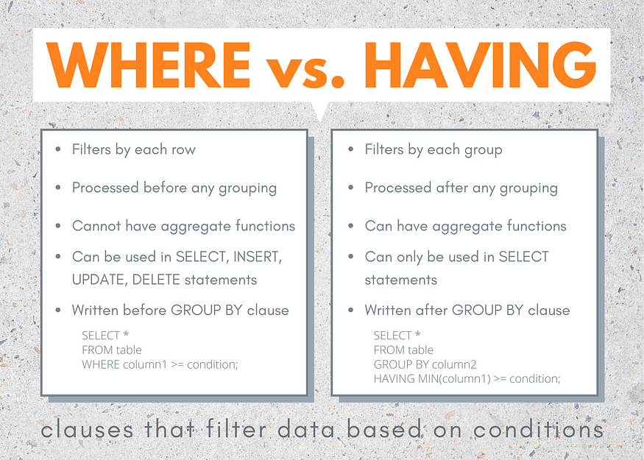

3. What is the use of group by?
The Group By statement is used for organizing similar data into groups. Often used with aggregate functions like COUNT, SUM, AVG, etc.
4. Types of Joins in SQL
- INNER JOIN: Returns rows that have matching values in both tables.
- LEFT JOIN (LEFT OUTER JOIN): Returns all rows from the left table, and matched rows from the right table.
- RIGHT JOIN (RIGHT OUTER JOIN): Returns all rows from the right table, and matched rows from the left table.
- FULL JOIN (FULL OUTER JOIN): Returns all rows when there is a match in either left or right table.
- CROSS JOIN: Returns the Cartesian product of the two tables.
5. What are triggers in SQL?
Imagine you have a small plant, and every time you water the plant, a little bell rings to remind you that the plant has been watered. You don't have to ring the bell yourself; it happens automatically when you water the plant.
In SQL, a trigger is like that little bell. It automatically does something when a specific action happens in the database. Let's use a simple scenario to explain it:
Scenario:
You have a table called plants to keep track of your plants and their watering schedule. You also have a table called notifications to keep a log of watering actions.
Whenever you water a plant (add a new row to the plants table with the date and time you watered it), a trigger automatically adds a new row to the notifications table to log this action.
SQL Example:
- plants table: This table stores information about when you water each plant.
sql
CREATE TABLE plants (
plant_id INT,
plant_name VARCHAR(50),
watered_at DATETIME
);
- notifications table: This table logs each watering action.
sql
CREATE TABLE notifications (
notification_id INT,
plant_id INT,
message VARCHAR(100),
logged_at DATETIME
);
- Trigger: This trigger automatically inserts a new log into the notifications table whenever a new watering action is recorded in the plants table.
sql
CREATE TRIGGER water_plant_trigger
AFTER INSERT ON plants
FOR EACH ROW
BEGIN
INSERT INTO notifications (plant_id, message, logged_at)
VALUES (NEW.plant_id, CONCAT('Watered ', NEW.plant_name), NEW.watered_at);
END;
How It Works:
- Action: You add a new record to the plants table with the date and time you watered the plant.
- Trigger: The trigger automatically inserts a new record into the notifications table, logging the action with a message saying "Watered [Plant Name]" and the date and time.
So, every time you water a plant (add a record to the plants table), the trigger automatically logs this action (adds a record to the notifications table) just like the bell rings every time you water your real plant. 🚿🌱🔔

6. What is stored procedure in SQL
A stored procedure is a set of SQL statements that you can save and reuse. It is like a recipe that you can follow whenever you need to cook a specific dish. Instead of writing the same SQL code over and over again, you save it as a stored procedure and call it when needed.
Scenario: Managing an Online Store
Imagine you run an online store and you frequently need to update the stock of products after a new shipment arrives. Instead of writing the same SQL statements each time to update the stock, you can create a stored procedure to do this task.
Why Use a Stored Procedure?
- Reusability: You write the code once and reuse it whenever needed.
- Maintenance: Easier to update and manage the SQL code in one place.
- Performance: Stored procedures are precompiled, so they can execute faster.
- Security: You can control access to the data by granting permissions to execute the stored procedure instead of direct access to the tables.
Example Stored Procedure
Let's create a stored procedure that updates the stock for a given product when a new shipment arrives.
- Create Tables: First, we have a products table to store product information.
sql
CREATE TABLE products (
product_id INT PRIMARY KEY,
product_name VARCHAR(100),
stock INT
);
- Insert Sample Data:
sql
INSERT INTO products (product_id, product_name, stock)
VALUES (1, 'Laptop', 10),
(2, 'Smartphone', 20);
- Create the Stored Procedure:
sql
CREATE PROCEDURE UpdateStock
@product_id INT,
@new_stock INT
AS
BEGIN
UPDATE products
SET stock = stock + @new_stock
WHERE product_id = @product_id;
END;
- Using the Stored Procedure: When a new shipment of 5 laptops arrives, you call the stored procedure to update the stock.
sql
EXEC UpdateStock @product_id = 1, @new_stock = 5;
This stored procedure updates the stock for the specified product by adding the new shipment quantity to the existing stock.
Summary:
Stored procedures help you automate and simplify repetitive tasks, improve performance, and enhance security. They are especially useful for complex operations that need to be performed regularly, like updating stock, processing orders, or generating reports.

7. Explain all types of window functions?
RANK(): Assigns a rank to each row within a partition of a result set.
ROW_NUMBER(): Assigns a unique sequential integer to rows within a partition.
DENSE_RANK(): Similar to RANK, but no gaps in ranking values.
LEAD(): Accesses data from the following row at a specified offset.
LAG(): Accesses data from the preceding row at a specified offset and
Aggregate functions.
Example for row_number()
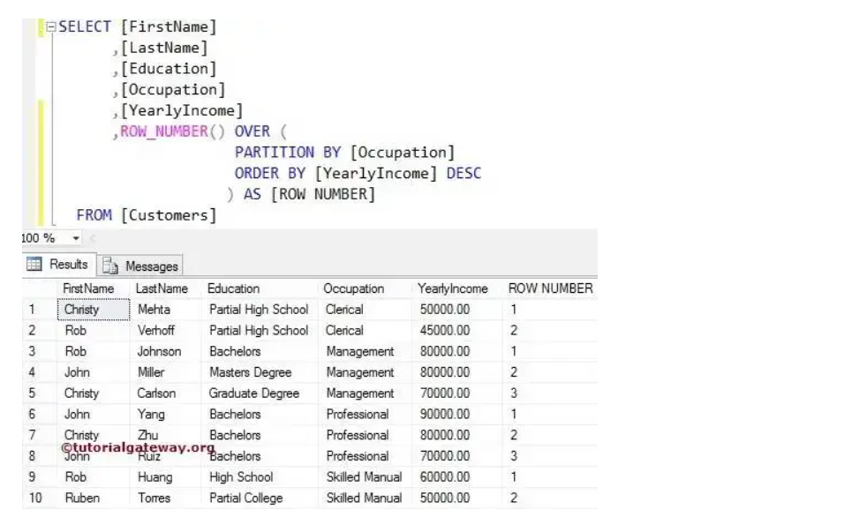
8. What is the difference between DROP vs DELETE vs TRUNCATE?
Drop- whole table remove
Truncate- Complete data delete. We cant retrieve
Delete- complete data delete. Data retrive.
In Truncate and delete- structure should be same.
9. What is difference between DML, DDL and DCL, TCL?
DML (Data Manipulation Language): INSERT, UPDATE, DELETE.
DDL (Data Definition Language): CREATE, ALTER, DROP.
DCL (Data Control Language): GRANT, REVOKE.
TCL(Transaction control Language): Rollback, savepoint,commit;
DQL: Select

10. CTE vs. Subquery
- Common Table Expressions (CTE): Temporary result set that is defined within the execution scope of a single SELECT, INSERT, UPDATE, or DELETE statement.
- Subquery: A query nested inside another query.
- CTEs are generally easier to read and maintain, especially for complex queries.
11. Constraints and Types of Constraints
- Constraints enforce rules at the table level.
- Types include:
  - PRIMARY KEY
  - FOREIGN KEY
  - UNIQUE
  - NOT NULL
  - CHECK
  - DEFAULT
12. Normalization
- The process of organizing data in a database to minimize redundancy.
- Normal forms:
  - 1NF: Eliminate duplicate columns.
  - 2NF: Remove subsets of data that apply to multiple rows of a table.
  - 3NF: Eliminate fields that do not depend on the primary key.
13. Difference between Group By and Where Clause
- GROUP BY: Aggregates data.
- WHERE: Filters data before aggregation.
14. View Concepts
A table which is created from parent table.
Virtual table
you can hide some details from parent table and can derive child table from it.

For Example: company table have details about google, youtube,tcs,cts but vendor is asking about google, we can’t give all company details so we are creating view to derive the child table abt google info.
Create view google_info as
select * from company where name='google';

select * from google_info;

15. Types of Constraints
- Refer to 11. Constraints and Types of Constraints above.
16. Difference between CHAR and VARCHAR
- CHAR: Fixed-length character data type.
- VARCHAR: Variable-length character data type.
17. Indexes and Types
- Indexes improve the speed of data retrieval.
- Types include:
  - Clustered Index
  - Non-Clustered Index
  - Unique Index
  - Full-Text Index
18. SQL Query to Find Names of Employees Starting with 'A'
sql
SELECT name FROM employees WHERE name LIKE 'A%';
19. Types of Clauses in SQL
- SELECT, FROM, WHERE, GROUP BY, HAVING, ORDER BY, LIMIT
20. UNION vs. UNION ALL
- UNION: Combines result sets and removes duplicates.
- UNION ALL: Combines result sets without removing duplicates.
21. Types of Relationships in SQL
- One-to-One
- One-to-Many
- Many-to-Many
22. Primary Key vs. Foreign Key
- Primary Key: Uniquely identifies each record in a table.
- Foreign Key: Establishes a link between records in two tables.
23. Second Highest Salary
Find the nth highest salary
select salary
from(select salary, Dense Rank() over(order by desc) as rank from emp)
where rank=5;
(or) 2nd highest sal
SELECT MAX(salary) FROM employees WHERE salary < (SELECT MAX(salary) FROM employees);

24. Function vs. Stored Procedure
- Function: Returns a value, can be used in a SELECT statement.
Function – aggregate func, string , date
- Stored Procedure: Performs actions, can accept parameters, and can execute SQL statements.
25. Optimizing a Slow SQL Query
- Use Indexes
- **Avoid SELECT ***
- Optimize Joins
- Use appropriate WHERE clauses
- Avoid unnecessary columns in SELECT
- Use EXPLAIN to analyze query execution plans
26. INNER JOIN vs. OUTER JOIN
- INNER JOIN: Returns rows with matching values in both tables.
- OUTER JOIN: Returns all rows from one table and the matched rows from the other.
27. Handling Duplicate Rows
- Use DISTINCT:
sql
SELECT DISTINCT column_name FROM table_name;
- Use GROUP BY:
sql
SELECT column_name, COUNT(*) FROM table_name GROUP BY column_name;
OR
SELECT column, COUNT(column) FROM table_name GROUP BY column HAVING COUNT(column) > 1;
SELECT name, email, COUNT(name) FROM student_contacts GROUP BY name HAVING COUNT(name) > 1;

To Display duplicate records:
select col_name from table.name minus select distinct col_name from table.name as dup_rec;

28. Top 3 Departments with Highest Average Salary
sql
SELECT department, AVG(salary) as avg_salary
FROM employees
GROUP BY department
ORDER BY avg_salary DESC
LIMIT 3;
29. Write a SQL query to find the employees who have the same name and work in the same department.
sql
SELECT name, department
FROM employees
GROUP BY name, department
HAVING COUNT(*) > 1;
30. Write a SQL query to find the departments with no employees.
sql
SELECT department
FROM departments
LEFT JOIN employees ON departments.id = employees.department_id
WHERE employees.id IS NULL;
31. Use of Indexing
- Indexes make retrieval faster by creating an internal data structure.
- Use on frequently queried columns.
32 . Write a SQL query to find the employees who have worked for more than 5 years.
sql
SELECT name
FROM employees
WHERE DATEDIFF(CURDATE(), join_date) > 365 * 5;
33. Subquery vs. JOIN
- Subquery: A query nested inside another query.
- JOIN: Combines rows from two or more tables.
34. Top 2 Products with Highest Sales
sql
SELECT product_name, SUM(sales) as total_sales
FROM sales
GROUP BY product_name
ORDER BY total_sales DESC
LIMIT 2;
35. Use of Stored Procedures
- Stored procedures improve performance by reducing network traffic and reusing code.
36. Customers Who Placed an Order but Not Made a Payment
sql
SELECT customer_name
FROM orders
LEFT JOIN payments ON orders.order_id = payments.order_id
WHERE payments.payment_id IS NULL;
37. Write a SQL query to find the employees who work in the same department as their manager.
sql
SELECT e1.emp_name AS employee, e2.emp_name AS manager, e1.department_id
FROM employees e1
JOIN employees e2 ON e1.manager_id = e2.emp_id
WHERE e1.department_id = e2.department_id;
38. How do you use window functions to solve complex queries?
- Window functions perform calculations across a set of table rows related to the current row.
- Useful for running totals, moving averages, etc.
39. Employees with No Leave in Last 6 Months
SELECT name
FROM employees
WHERE id NOT IN (
SELECT employee_id
FROM leaves
WHERE leave_date > DATE_SUB(CURDATE(), INTERVAL 6 MONTH)
);

40. What is the difference between Cluster and Non-Cluster Index?

41. Why do we use Commit and Rollback commands?
COMMIT:
- The COMMIT command is used to save all changes made during the current transaction.
- Once a transaction is committed, the changes are permanent and visible to other users and processes.
Example:
sql
BEGIN TRANSACTION;
UPDATE employees SET salary = salary + 5000 WHERE emp_id = 1;
COMMIT;
ROLLBACK:
- The ROLLBACK command is used to undo all changes made during the current transaction.
- If an error occurs or you need to revert the changes, you can use ROLLBACK to restore the database to its previous state before the transaction began.
Example:
sql
BEGIN TRANSACTION;
UPDATE employees SET salary = salary + 5000 WHERE emp_id = 1;
-- Suppose an error occurs here
ROLLBACK;

